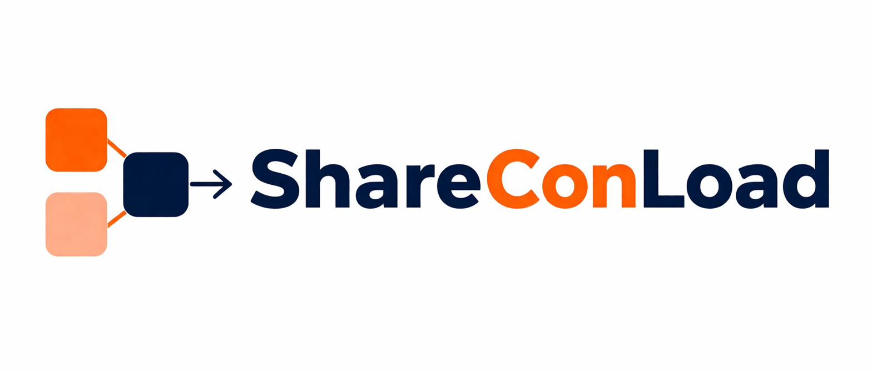
OPERATOR AGREEMENT
ShareConLoad Digital Logistics Marketplace
Effective Date: 09 May 2026
This Operator Agreement ("Agreement") governs participation by transport operators and carriers ("Operator", "Carrier", or "you") on the ShareConLoad platform operated by VEYQON GROUP (Pty) Ltd, registration number 2026/353683/07 ("ShareConLoad", "Platform", "we", "us", or "our").
By registering as an Operator or using the Platform, you agree to be bound by this Agreement.

1. PURPOSE OF THE AGREEMENT
1.1 ShareConLoad operates a digital logistics marketplace platform connecting cargo owners with independent transport operators for shared-container maritime shipping services.
1.2 This Agreement establishes:
▸ Operational responsibilities
▸ Payment terms
▸ Compliance obligations
▸ Dispute handling processes
▸ Participation requirements for Operators using the Platform

2. INDEPENDENT OPERATOR STATUS
2.1 Operators are independent contractors and not employees, agents, partners, joint ventures, or representatives of ShareConLoad.
2.2 Operators remain solely responsible for:
▸ Transport execution
▸ Shipment operations
▸ Cargo handling
▸ Staffing
▸ Compliance obligations
▸ Operational decision-making
2.3 Nothing in this Agreement creates an employment or agency relationship between the parties.

3. OPERATOR ELIGIBILITY REQUIREMENTS
3.1 Operators must maintain:
▸ Lawful business registration
▸ Valid operational licenses and permits
▸ Applicable tax registrations
▸ Operational bank accounts
▸ Cargo liability insurance
▸ All legally required shipping authorizations
3.2 ShareConLoad may request updated compliance documentation at any time.
3.3 Failure to maintain valid operational or compliance documentation may result in:
▸ Account suspension
▸ Payout withholding
▸ Termination from the Platform

4. OPERATOR VERIFICATION
4.1 ShareConLoad reserves the right to conduct:
▸ Company verification
▸ Compliance reviews
▸ Identity checks
▸ Operational assessments
▸ Risk evaluations
4.2 Operators authorize ShareConLoad to verify submitted information through lawful third-party sources where necessary.
4.3 ShareConLoad may reject or suspend Operators where:
▸ Information is inaccurate
▸ Verification fails
▸ Fraud is suspected
▸ Operational risk is identified

5. OPERATOR OBLIGATIONS
Operators agree to:
▸ Provide accurate shipment schedules
▸ Maintain lawful shipping operations
▸ Communicate delays promptly
▸ Comply with customs and regulatory requirements
▸ Handle Cargo responsibly
▸ Maintain professional conduct
▸ Protect shipment documentation
▸ Fulfill confirmed shipment obligations in good faith

Operators must ensure all shipment information provided on the Platform remains accurate and updated.

6. SHIPMENT EXECUTION RESPONSIBILITY
6.1 Operators remain solely responsible for:
▸ Shipment execution
▸ Loading and unloading operations
▸ Cargo handling
▸ Routing and transport management
▸ Customs compliance
▸ Delivery performance
6.2 Operators accept liability for operational failures within their reasonable control.
6.3 ShareConLoad does not assume responsibility for physical shipment execution.

7. PAYMENT AND SETTLEMENT STRUCTURE
7.1 ShareConLoad facilitates conditional payment coordination between Customers and Operators and is not a banking institution, escrow provider, or financial institution.

7.2 Customer payments are structured as follows:

Payment Stage | Customer Payment
Booking confirmation | 20%
Seven (7) days before departure | 50%
Before cargo release at destination | 30%

7.3 Operator payouts shall generally follow the structure below, less applicable Platform fees and adjustments:

Payment Stage | Operator Payout
Booking confirmation and Operator acceptance | 20%
Confirmed vessel departure | 50%
Cargo release and final customer payment confirmation | 30%

7.4 ShareConLoad reserves the right to:
▸ Delay payouts during investigations
▸ Adjust settlements for disputes
▸ Deduct applicable platform fees
▸ Withhold payouts where operational risks or violations are identified
7.5 Payout timing may vary depending on:
▸ Banking systems
▸ Payment processors
▸ Compliance reviews
▸ Operational verification processes

8. PLATFORM FEES
8.1 Operators agree to pay applicable Platform fees, commissions, or service charges as communicated by ShareConLoad.
8.2 ShareConLoad may deduct applicable fees directly from settlement payouts.
8.3 Platform fee structures may be updated from time to time with reasonable notice.

9. OPERATOR CANCELLATIONS
9.1 Operators may not unreasonably cancel confirmed Shipments.
9.2 Where an Operator cancels or fails to perform a confirmed Shipment, ShareConLoad may:
▸ Suspend payouts
▸ Issue customer refunds or credits
▸ Arrange replacement Operators
▸ Apply operational penalties
▸ Reduce Operator ratings
▸ Suspend Platform access
9.3 Repeated cancellations or operational failures may result in permanent removal from the Platform.

10. PERFORMANCE MANAGEMENT
10.1 ShareConLoad may monitor Operator performance, including:
▸ Shipment completion rates
▸ Customer complaints
▸ Communication responsiveness
▸ Dispute frequency
▸ Delay history
▸ Operational reliability
10.2 ShareConLoad may apply:
▸ Trust scores
▸ Ranking adjustments
▸ Operational warnings
▸ Temporary restrictions
▸ Suspensions based on performance assessments
10.3 ShareConLoad reserves the right to prioritize reliable Operators within Platform listings and operational workflows.

11. DISPUTES AND INVESTIGATIONS
11.1 ShareConLoad may investigate:
▸ Customer complaints
▸ Shipment disputes
▸ Cargo claims
▸ Operational failures
▸ Suspected misconduct
11.2 Operators agree to cooperate fully with investigations, including providing:
▸ Shipment records
▸ Communications
▸ Customs documentation
▸ Proof of delivery
▸ Supporting operational evidence
11.3 ShareConLoad may temporarily freeze payouts while disputes are under investigation.
11.4 ShareConLoad may issue reasonable operational decisions based on available evidence and Platform records.

12. INSURANCE REQUIREMENTS
12.1 Operators must maintain appropriate:
▸ Cargo liability insurance
▸ Operational insurance
▸ Legally required shipping coverage
12.2 Operators remain solely responsible for claims relating to:
▸ Cargo damage
▸ Cargo loss
▸ Theft
▸ Shipment mishandling
▸ Operational negligence
12.3 ShareConLoad may request proof of insurance at any time.

13. PROHIBITED ACTIVITIES
Operators may not:
▸ Transport prohibited goods unlawfully
▸ Submit false shipment information
▸ Manipulate bookings or pricing
▸ Engage in fraudulent conduct
▸ Misuse customer information
▸ Bypass Platform payment processes
▸ Violate applicable laws

14. CONFIDENTIALITY
Operators shall maintain confidentiality regarding:
▸ Customer information
▸ Shipment records
▸ Pricing information
▸ Platform systems
▸ Operational data

Confidential information may only be used for legitimate shipment execution purposes.

15. DATA PROTECTION
Operators agree to process personal information responsibly and in compliance with applicable privacy and data protection laws.

Operators may only use customer information for lawful shipment-related purposes.

16. LIMITATION OF LIABILITY
16.1 ShareConLoad acts solely as a technology marketplace facilitating shipment transactions between Customers and Operators.
16.2 ShareConLoad shall not be liable for:
▸ Operational shipment failures
▸ Cargo damage or loss
▸ Customs actions
▸ Port delays
▸ Commercial losses
▸ Indirect damages arising from Operator activities
16.3 To the maximum extent permitted by law, ShareConLoad's liability shall be limited to amounts directly received by the Platform in connection with the affected Shipment.

17. SUSPENSION AND TERMINATION
17.1 ShareConLoad may suspend or terminate Operator access where:
▸ Fraud is suspected
▸ Compliance obligations are breached
▸ Insurance expires
▸ Repeated operational failures occur
▸ Customer complaints increase materially
▸ Legal or regulatory risks arise
17.2 Operators may request account termination in writing, subject to settlement of outstanding obligations and active disputes.

18. FORCE MAJEURE
Neither party shall be liable for delays or failures caused by events beyond reasonable control, including:
▸ Natural disasters
▸ War
▸ Strikes
▸ Port congestion
▸ Customs actions
▸ Cyber incidents
▸ Political unrest
▸ Transportation disruptions

19. GOVERNING LAW
This Agreement shall be governed by and interpreted in accordance with the laws of the Republic of South Africa.

20. DISPUTE RESOLUTION
20.1 Parties shall first attempt to resolve disputes through good-faith negotiations.
20.2 Where disputes remain unresolved, parties agree to attempt mediation before initiating formal litigation.
20.3 Nothing prevents either party from seeking urgent legal relief where necessary.

21. AMENDMENTS
ShareConLoad reserves the right to amend this Agreement from time to time.

Updated versions become effective upon publication or notification through the Platform.

Continued use of the Platform constitutes acceptance of revised terms.

AGREED AND ACCEPTED

By signing below, both parties confirm they have read, understood, and agree to be bound by this Operator Agreement.

VEYQON GROUP (Pty) Ltd  Authorised Signatory  Name & Title  Date |  | Operator / Carrier  Authorised Signatory  Name & Title  Date

22. CONTACT INFORMATION
VEYQON GROUP (Pty) Ltd
Registration Number: 2026/353683/07
Republic of South Africa
Website: shareconload.com
Email: support@shareconload.com

Share the Load. Connect the World.

